Sir Eric Woodward School Uniform

Dear Parents/Caregivers

SEWS has updated their uniform with the new logo sewn on both the white polo shirt (short and long sleeve) and the navy blue zip up jacket .

Our school uniform consists of:

Summer - White polo shirt, dark navy blue shorts/navy trousers.
Winter - White skivvy/white long sleeve polo with navy blue tracksuit pants.
The hat is either a navy blue broad brimmed hat or a legionnaire’s hat.

SEWS school uniform gives our students a distinct identity especially when they are on excursions and out in the community.

The school stocks the uniform in a variety of sizes which have the school logo embroidered on them (please see the attached pricing form).
The items of clothing without logo are available from Big W and Lowes and are reasonably priced.

SEWS is also happy to announce we now have back packs (with the school logo) and navy blue clothes protectors (cravats) for sale.

It would be appreciated if all items of school uniform could be labelled clearly with the student’s name.
Summer Uniform  - White polo shirt  - Navy blue knit/drill shorts  - Navy Trousers | Winter Uniform  - White long sleeved polo shirt or Skivvy  - Navy blue Tracksuit pants  - Navy blue zip jacket | Other Uniform  - Navy blue back pack with logo  - Navy blue clothes protector (cravat)  - Navy blue broad brim or legionnaires hat
New School Backpack

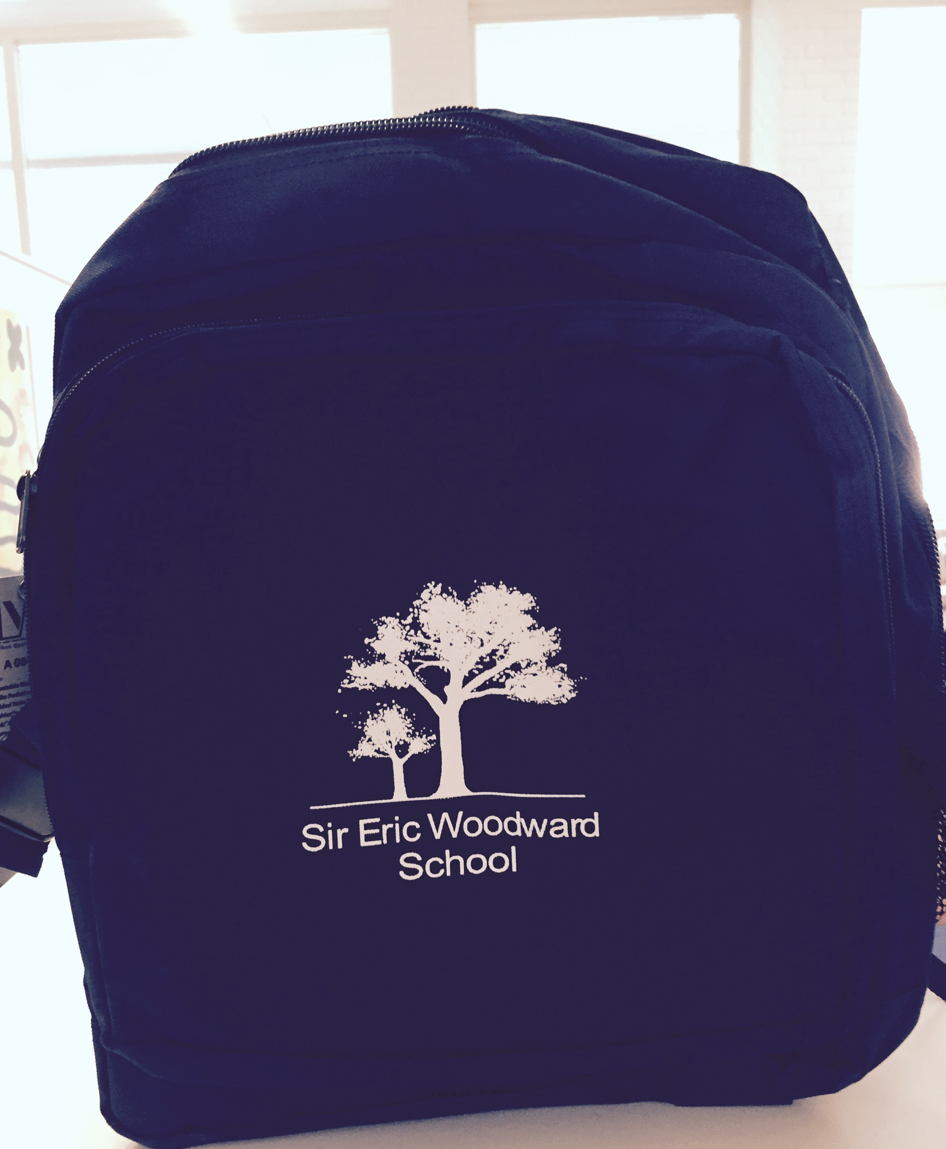
New School Logo

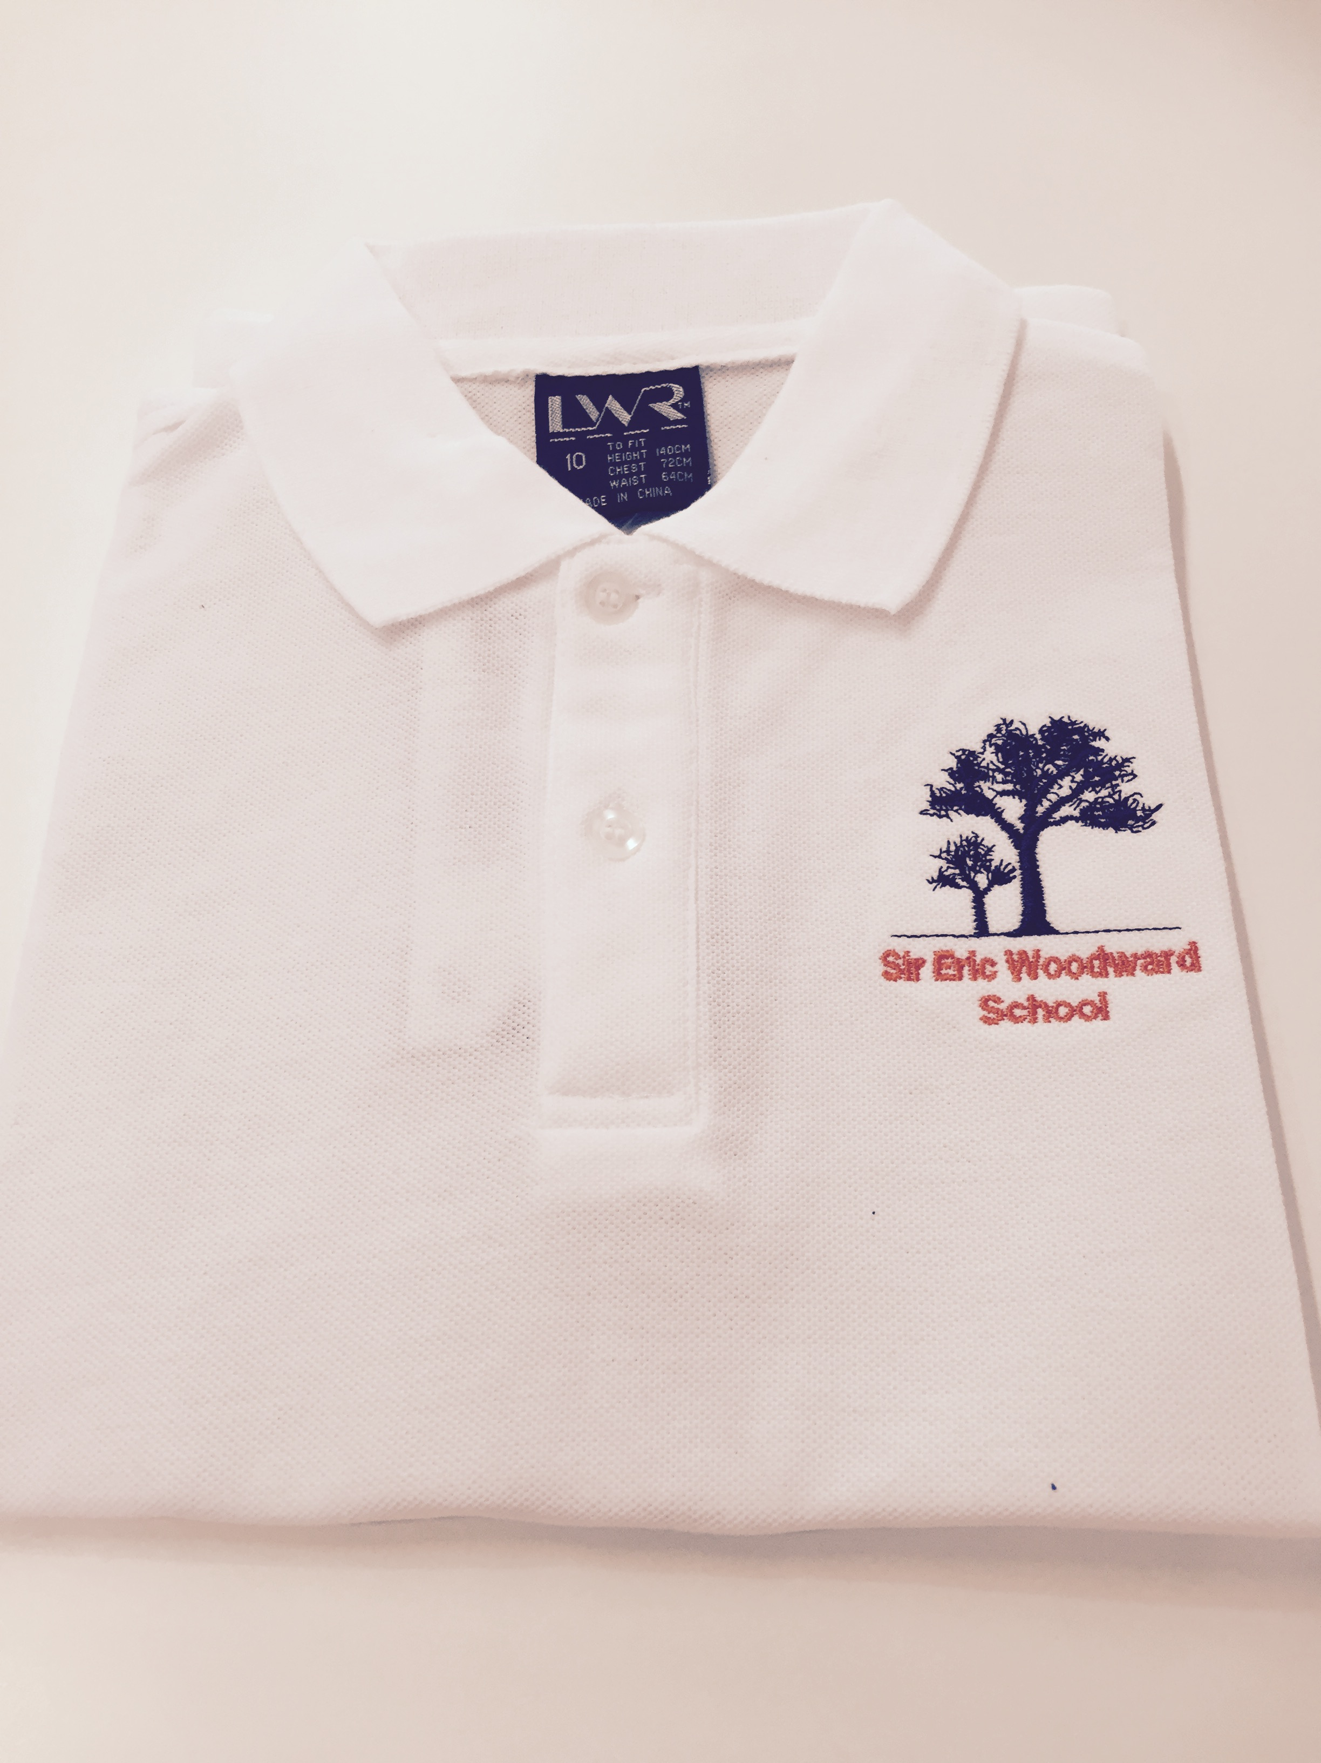
Full School Uniform with Broad Brim Hat

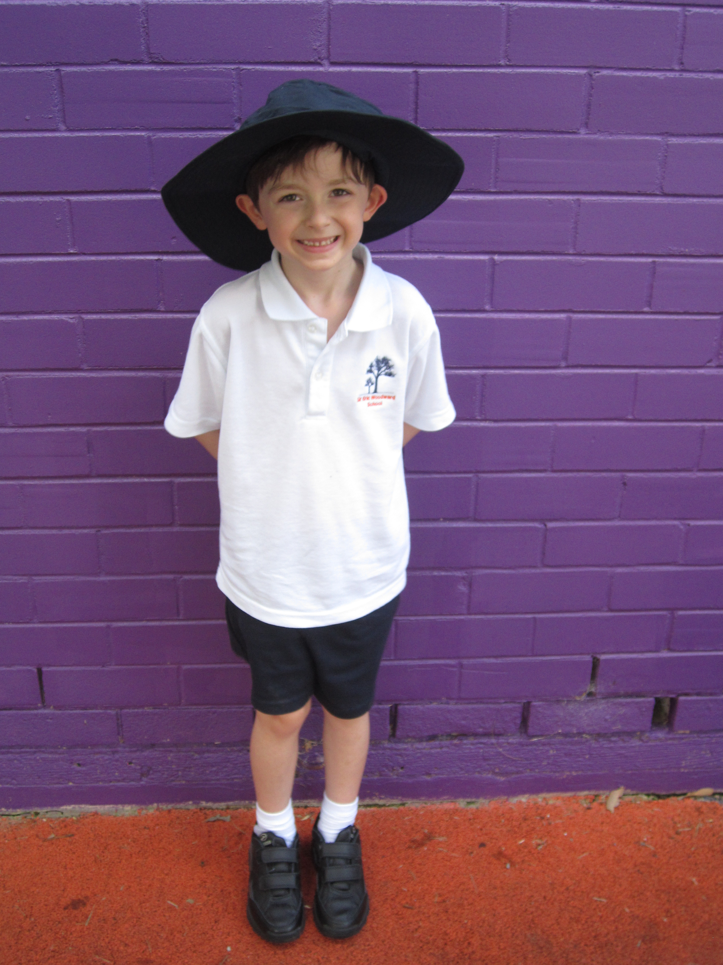

SCHOOL UNIFORM ORDER FORM

NAME OF STUDENT: DATE:

Item | Cost per Item  (inc GST) | Quantity | Size | Total $ Cost | Office Use Only
Summer uniform |  |  |  |  | Date  Supplied | Invoice  Sent
White shirt with collar (short sleeve) | $16.00
Navy summer shorts  (Sz 4-16Y) | $12.00
Navy summer shorts  (Sz S/M/L) | $15.00
Winter uniform |  |  |  |  | Date  Supplied | Invoice  Sent
White polo shirt (long sleeve) Sz 4-16Y | $18.00
White polo shirt (long sleeve) Sz S/M/L | $21.00
Navy front zip fleecy top (Sz 4-16Y) | $24.00
Navy front zip fleecy top (Sz S/M/L) | $30.00
Navy fleecy tracksuit  (Sz 4-16Y) | $16.00
Navy fleecy tracksuit  (Sz S/M/L) | $22.00
Navy hat - broad brim | $11.00 |  | One Size Fits All
Navy legionnaires hat | $5.00
Navy adventurer backpack | $32.00
Library bag | $6.00
Cravat | $10.00

